8 Mind-Blowing Abraham Hicks Videos
Do a search for Abraham Hicks in YouTube and you'll find over 1M hits. Now not all of them are Abraham talks, but thousands of them are.

As a result, it's hard to wade through all the videos and find the gems that will appeal to you. And that's why I put together this list of (definitely not exhaustive) videos, which shift your vibration, make you see things in a new light, inspire you and more.

So happy viewing and please leave a comment at the bottom if you have any Abraham videos you'd like to add.

Video 1:

Abraham Hicks: How easy it's to get a lot of money, just apply the simple rule


This video is 11:11 and the topic focuses on how to get the “big” money in your life. “Big” is in quotes because Abraham highlights the issue with classifying money as “big” or “not big”. The issue being that the very classification of “big” implicitly equates to something that is harder to attain.

When you consider something harder to attain, then you’re adding resistance to the coming of that desire. Abraham then proceeds to offer a formula to remedy these thoughts and help you get in the right vibrational state to manifest whatever it is you desire.

Video 2:

Abraham Hicks - The easiest way to start positive momentum



This video is 14:28 and focuses on the easiest way to start down the path of positive momentum, even when nothing seems to be going right in your life. Abraham’s advice is to go general and what that means is explained in the video, including a detailed rampage of general positive momentum. And these examples can be applied by everyone.

Abraham also highlights that positive momentum is just that; momentum that you can get swept up in for any subject you can imagine. And that’s because law of attraction also attracts like thoughts to you. So if you’re focusing on something that makes you feel good, for example, then more feel good thoughts will come to you. And when you’re in this mode the amount of resistance you feel goes down significantly.

Further, once this positive momentum becomes a habit, then you will attract others in the same vibrational field as you.

Video 3:
Abraham Hicks ~ Let go and Dream Big

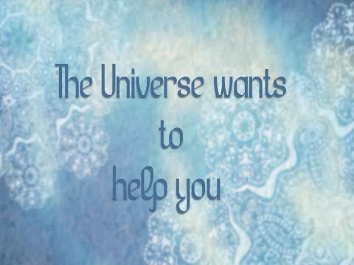

In this video, Abraham identifies a common issue that most people have when it comes to their desires, and that’s namely the issue that our desires have yet to manifest in our physical reality.

And because we place our feeling good on the condition of manifesting that desire, we choose not to pay attention to our desires because we find it painful to think about, because it’s not yet here.

In other words, we hold ourselves in resistance to the allowing of our own manifestations by ignoring our desires.

But this doesn’t have to be the case. We can decide to feel good regardless of whether we have achieved our desire or not. And that’s because we’ll never run out of our desires.

We’ll never stop wanting more, so placing your happiness on the achievement of our desires will result in us never feeling good.

An alternative is to feel good without the manifestation. In fact you can feel good about the desire by focusing your attention on how good it will feel once you have it. You just have to activate that positive vibration within you.

Video 4:

Abraham-Hicks/ Change vibration instantly


This video is 14:37 and focuses on techniques you can use to deactivate a limiting belief (which is really a very active vibration) and eventually replace it with more aligned beliefs.

Some suggestions include not talking about your beliefs (or at least talking about it less than before) and if you find yourself in a conversation with someone who brings that belief up, knowing how to respond to lessen the active part of it.

Abraham also identifies how to treat yourself when you do find yourself thinking or talking about that limited belief, specifically focusing on not judging yourself for thinking it in the first place.

The whole objective is to bring some awareness into how you feel, what to say and how to behave, with the intention of shifting your focus from unwanted things to wanted things.

Abraham then takes the concept to the next level, highlighting what will naturally happen to you when you deactivate your limiting beliefs. What’s said in this part of the talk is profound and helps you understand deliberate creation in a new way.

Video 5:

Abraham Hicks: Heal yourself, start regenerating your body cells, become young and strong again


This video is 10:40 and focuses on how to heal your physical body. Abraham goes into some detail about the cells in our body and how they are regenerated and also what the cells represent in terms of our connections with source.

When left to their own devices, our cells know how to automatically fix any imbalances in our body and bring our body’s back to perfect health.

What affects our cells though is the mind and what we think and how we feel. In other words we are the gatekeepers of how our body feels by either allowing our natural well being to flow or not.

Finally, Abraham offers advice about how to allow when you’re not feeling well.

Video 6:

Abraham-Hicks~ How to be unconditionally HAPPY!


This video is 15:27 and focuses on being happy no matter what's going on in your life.

This was touched upon in another video, but this one really gets at the heart of it. Essentially, we are all looking for the condition of the manifestation to occur before allowing ourselves to feel good.

The issue is the desires that precede the manifestations are loaded with our past beliefs and conditionings and therefore automatically introduce resistance into the equation.

To explain this in some more detail, a desire is born out of contrast. Meaning an unwanted experience causes us to desire something we don’t have in our lives (usually the opposite of the unwanted experience). So, if you can’t pay your next bill for example, then the desire for more money comes about.

However, the wanting of money, to continue the example, is loaded with the bad feelings that comes from not paying the bill and keeps you focused on the fact that you don’t have the money, making you feel worse.

And now you’ve created the condition of having money before feeling good. “My bad feeling associated with not paying the bill will go away once I have the money.”

Unfortunately, you’re stuck in the vibration of “not having enough money” meaning you’ll continue to attract the like vibration of “not having enough money”.

Instead you need to do the opposite. You need to feel good first and then the manifestation will come. You become happy by gaining momentum and aligning with who-you-really are. And then the ideas start to flow, the inspirations start coming and the coincidences start to show up.

The key takeaway is to feel good no matter what.

Video 7:

Abraham-Hicks | Signs MANIFESTATION is NEAR!

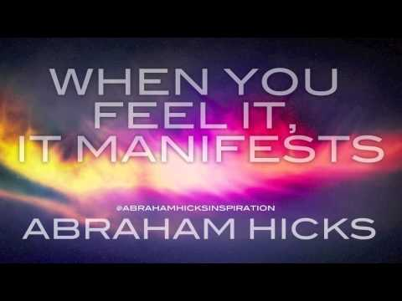
This video is 14:25 and at the beginning focuses on when to use certain tools such as meditation and visualization during the manifestation process.

More specifically, meditation is to be used to kind of reset your vibrational patterns allowing for more positive vibrations to flow through your experience, whereas visualization is better when you’re in a positive state and the actual process of visualization adds to the already good feeling.

Abraham then expands on the concept by highlighting signs that manifestation is near. The first thing you need to recognize and accept is that the manifestation has already occurred at a vibrational level.

Then ideas start to flow. You’re becoming clearer about the next steps to take. You start feeling good about that desire, even though it hasn’t shown up in your physical reality. You also have positive expectation about the manifestation.

This though can only work as long as you’re not offering resistance to it. Meaning not being discouraged by the absence of it or upset or anxious. In other words, like Abraham’s message in the other videos, you have to unconditionally feel good first.

Abraham also reinforces that you don’t need to try so hard to get the manifestation. Allow it to come into your experience. Allow the ideas and thoughts to come to you instead of trying to figure it out.

Video 8:
Abraham Hicks - Are There Spiritual Forces With Us


This video is 12:30 and the first 7 minutes focuses on a topic completely unrelated from the title of the video.

The topic focuses on how to feel about the contrast. For those unfamiliar with the teachings of Abraham, contrast is the first step in the formation of a desire.

When you experience something you don’t want, a desire associated with what you do want is born. That experience is called contrast.

Oftentimes we feel bad when we experience contrast and the reason is because we condemn ourselves for feeling bad.

Abraham clarifies that contrast is a necessary step of the manifestation process that will always be there, whether you want it to or not. It’s the genesis of expansion and no matter how hard you try, it will always be there.

Therefore, it makes more sense to recognize it as a necessary step in the process and more importantly the start of a delicious new manifestation. The main message, therefore is when you experience contrast in the future, make sure to go easy on yourself and recognize it for the value contained within it.

The second part of the video answers the question asked in the title. The short answer is yes, in fact we ourselves are spiritual forces, or in other words we’re much more than our physical selves. We are non-physical beings in a physical body.

So, there you have it. 8 videos that will you see the world in a new way and understand why you do the thins you do and how to feel good no matter what.

